**Lab 3: Data Query Language (DQL)**

**Objectives:**

The objective of these Data Query Language (DQL) exercises is to enhance the understanding and practical application of SQL queries within a relational database context. Specifically, the exercises aim to improve the ability to retrieve specific data from various tables such as customers, employees, suppliers, and orders in a database like Northwind. By performing tasks like filtering data based on conditions, projecting specific columns, and aggregating data using group functions, the exercises also intend to strengthen the user's proficiency in writing and optimizing SQL queries for different scenarios.

1. **Data Import:**
2. **Download northwind-db.sql from classroom link**
3. **Open MySQL Workbench and Login using root or <name>**
4. **Create database <name>northwind**

**Query:**

create database sulavadhikari_northwind;

**Output:**

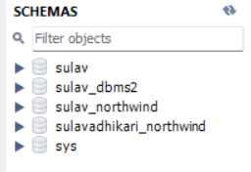

1. **Import downloaded database in <name>northwind**

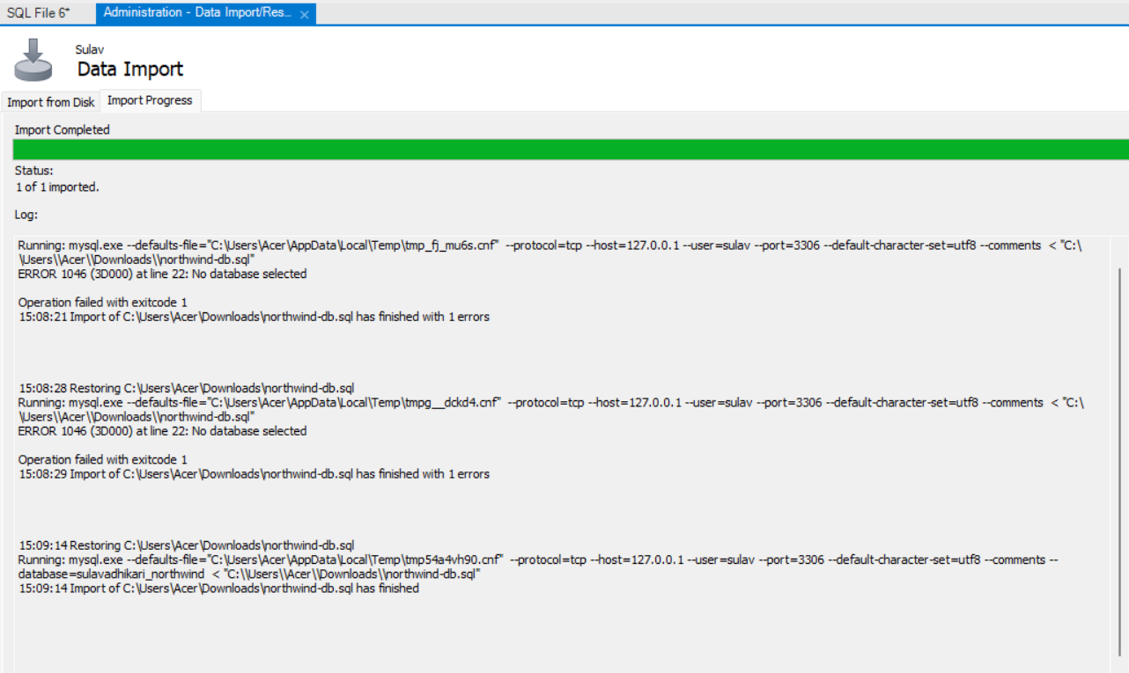**Output:**

1. **Data QUERY Languages (DQL)**
2. **Project CategoryName from categories**

**Query:**

SELECT CategoryName FROM categories;

**Output:**

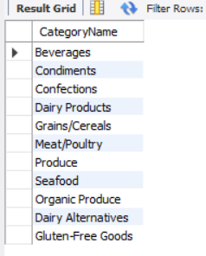

1. **Project country from customers**

**Query:**

SELECT Country FROM customers;

**Output:**

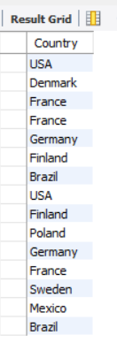

1. **Project city, country from customers**

**Query:**

SELECT City, Country FROM customers;

**Output:**

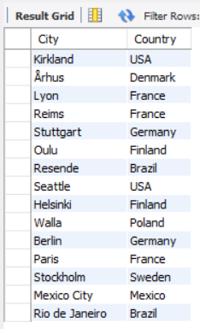

1. **SELECT CustomerName from customers who are from Paris City**

**Query:**

SELECT CustomerName FROM customers WHERE City = 'Paris';

**Output:**

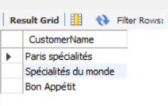

1. **SELECT CustomerID from customers who are from Spain**

**Query:**

SELECT CustomerID FROM customers WHERE Country = 'Spain';

**Output:**

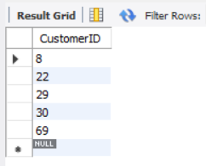

1. **SELECT CustomerID, CustomerName from customers who are from Mexico or Italy**

**Query:**

SELECT CustomerID, CustomerName FROM customers WHERE Country IN ('Mexico', 'Italy');

**Output:**

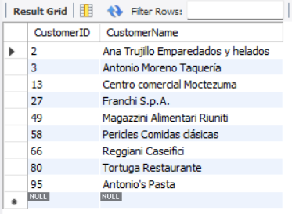

1. **SELECT all from customers who are from Frankfurt a.M. and Germany**

**Query:**

SELECT * FROM customers WHERE City = 'Frankfurt a.M.' AND Country = 'Germany';

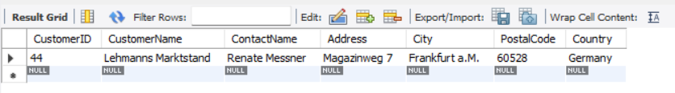**Output:**

1. **SELECT all from customers who are from city having names that start with first letter of Your Name.**

**Query:**

SELECT * FROM customers WHERE City LIKE 'S%';

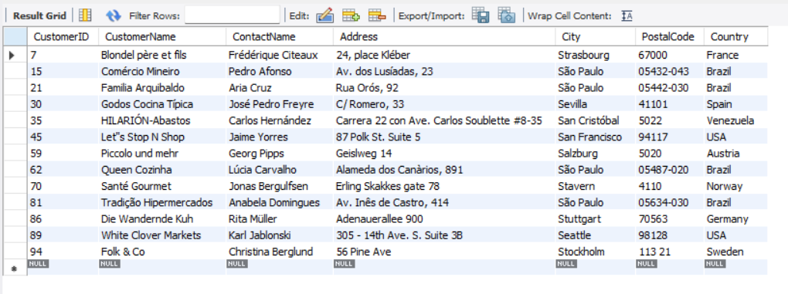**Output:**

1. **SELECT all from customers who are not from Venezuela or Argentina**

**Query:**

SELECT * FROM customers WHERE Country NOT IN ('Venezuela', 'Argentina');

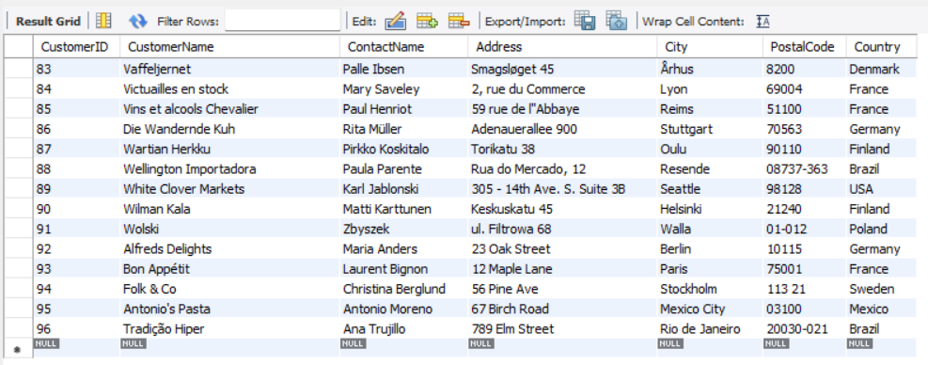**Output:**

1. **SELECT all from customers who are from G7 Countries**

**Query:**

SELECT * FROM customers WHERE Country IN ('United States', 'Canada', 'France', 'Germany', 'Italy', 'Japan', 'United Kingdom');

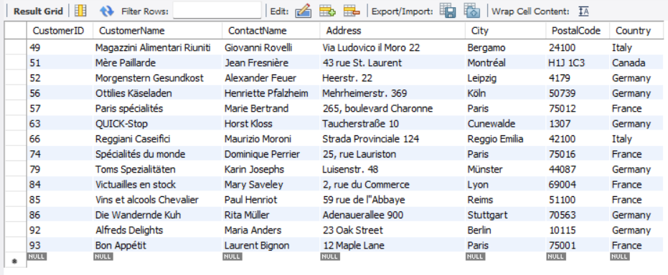**Output:**

1. **SELECT all from customers who have PostalCode containing 50**

**Query:**

SELECT * FROM customers WHERE PostalCode LIKE '%50%';

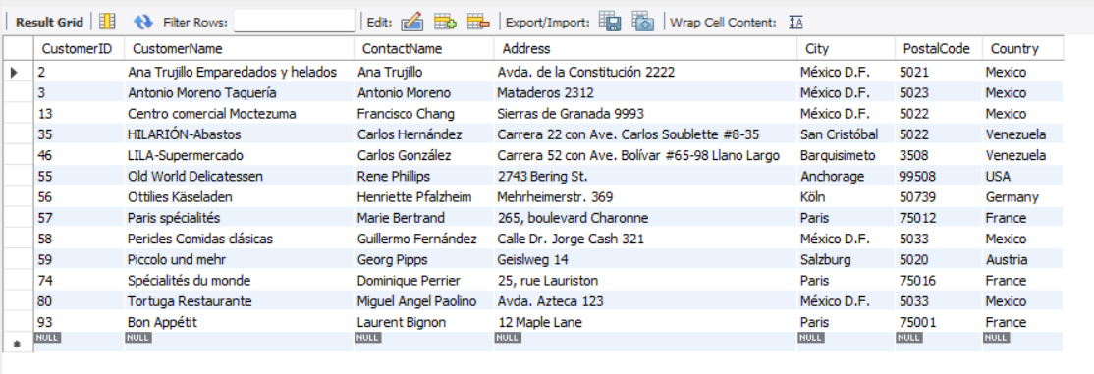**Output:**

1. **SELECT all from customers having PostalCode containing 31 and from Mexico City or Toulouse.**

**Query:**

SELECT * FROM customers WHERE PostalCode LIKE '%31%' AND (City = 'Mexico City' OR City = 'Toulouse');

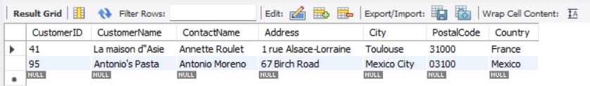**Output:**

1. **SELECT all from customers who are not from Elgin**

**Query:**

SELECT * FROM customers WHERE City != 'Elgin';

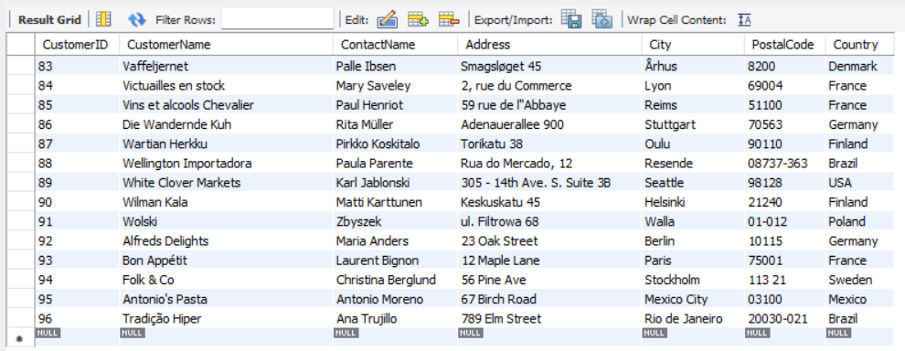**Output:**

1. **SELECT all employees who are born on July**

**Query:**

SELECT * FROM employees WHERE MONTH(BirthDate) = 7;

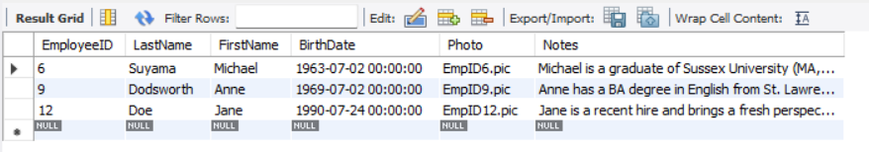**Output:**

1. **SELECT all employees having BA degree in Notes**

**Query:**

SELECT * FROM employees WHERE Notes LIKE '%BA%';

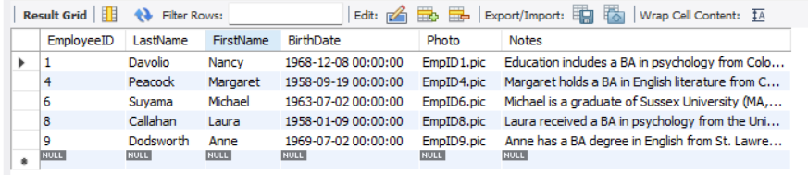**Output:**

1. **SELECT all suppliers from Australia and Sweden**

**Query:**

SELECT * FROM suppliers WHERE Country IN ('Australia', 'Sweden');

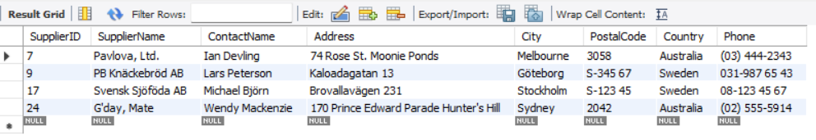**Output:**

1. **Find name and count of suppliers from different countries.**

**Query:**

SELECT Country, COUNT(SupplierID) AS SupplierCount FROM suppliers GROUP BY Country;

**Output:**

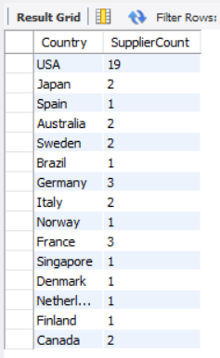

1. **Find name and count of customers from different cities.**

**Query:**

SELECT City, COUNT(CustomerID) AS CustomerCount FROM customers GROUP BY City;

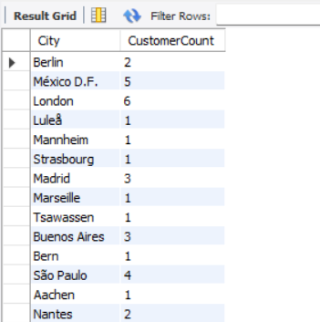**Output:**

1. **Find number of orders made by employee along with employeeID**

**Query:**

SELECT EmployeeID, COUNT(OrderID) AS OrderCount FROM orders GROUP BY EmployeeID;

**Output:**

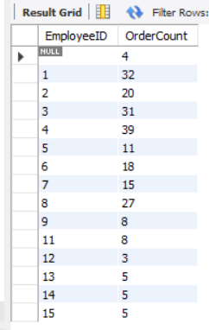

1. **Find number of orders made by customers along with customerID**

**Query:**

SELECT CustomerID, COUNT(OrderID) AS OrderCount FROM orders GROUP BY CustomerID;

**Output:**

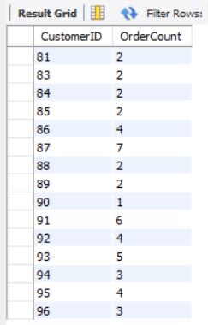

1. **Find all order that are shipped by shippers having 2 or 4 shipperID**

**Query:**

SELECT * FROM orders WHERE shipperID IN (2, 4);

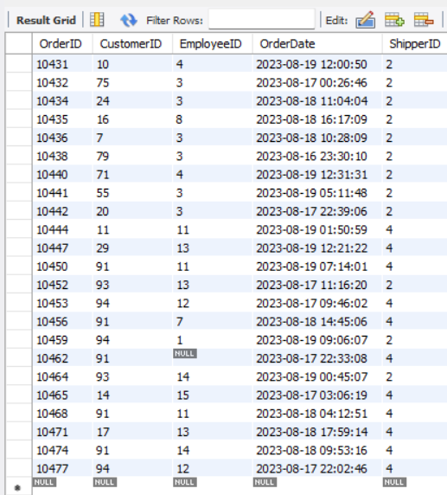

**Output:**

1. **SELECT all product having categoriesID 5**

**Query:**

SELECT * FROM products WHERE CategoryID = 5;

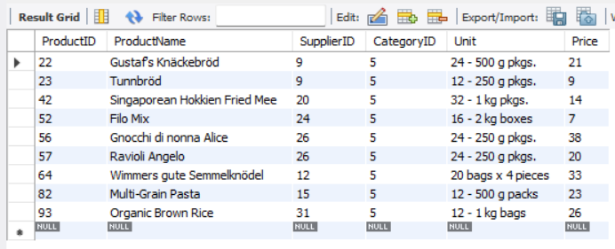**Output:**

1. **SELECT all products having ProductName that starts with First Letter of your name.**

**Query:**

SELECT * FROM products WHERE ProductName LIKE 'S%';

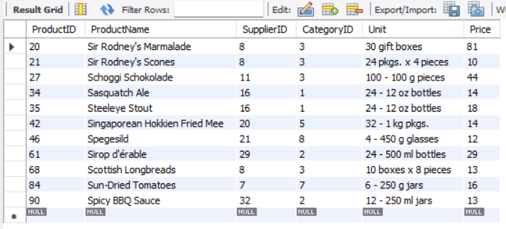**Output:**

**Conclusion:**

Through these DQL exercises, users gain hands-on experience in querying relational databases, an essential skill for managing and analyzing data effectively. The exercises cover a wide range of query types, from simple data retrieval to more complex aggregations and conditional filtering, providing a solid foundation in SQL. Mastering these queries will empower users to extract meaningful insights from large datasets and apply these skills in real-world database management and analysis tasks.